**Estimation And Prediction Of Hospitalization And Medical Care Costs**

Medical costs are one of the most common recurring expenses in a person's life. Based on different research studies, BMI, ageing, smoking, and other factors are all related to greater personal medical care costs. The estimates of the expenditures of health care related to obesity are needed to help create cost-effective obesity prevention strategies. Obesity prevention at a Young age is a top concern in global health, clinical practice, and public health.

**Technical Architecture:**

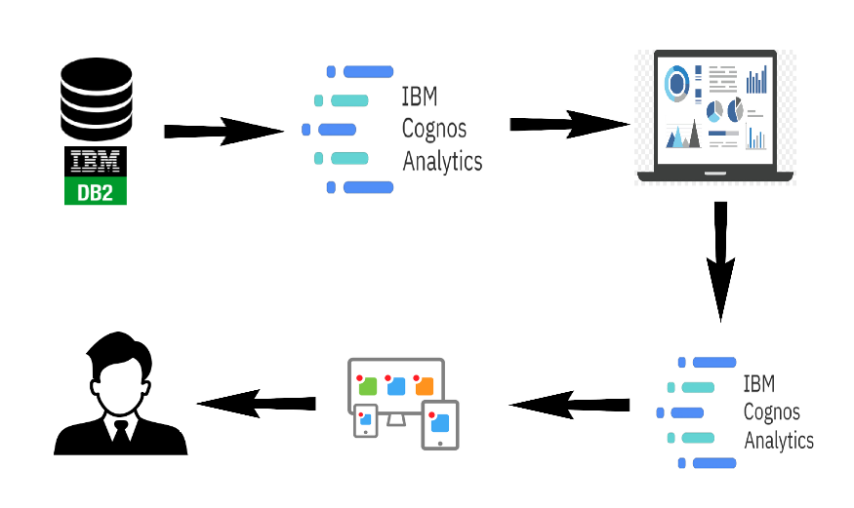

**Project Flow**

**Project Flow**

To accomplish this, we have to complete all the activities listed below,

* Define Problem / Problem Understanding
  + Specify the business problem
  + Business requirements
  + Literature Survey
  + Social or Business Impact.
* Data Collection & Extraction from Database
  + Collect the dataset,
  + Connect IBM DB2 with IBM Cognos
* Data Preparation
  + Prepare the Data for Visualization
* Data Visualizations
  + No of Unique Visualizations
* Dashboard
  + Responsive and Design of Dashboard
* Story
  + No of Scenes of Story
* Report
  + Creating a Report
* Performance Testing
  + Amount of Data Rendered to DB ‘
  + Utilization of Data Filters
  + No of Calculation Fields
  + No of Visualizations/ Graphs
* Web Integration
  + Dashboard and Story embed with UI With Flask
* Project Demonstration & Documentation
  + Record explanation Video for project end-to-end solution
  + Project Documentation-Step by step project development procedure

### Define Problem / Problem Understanding

A problem statement is a clear and concise description of the issue or challenge that needs to be addressed. It should define the problem in a way that is understandable to stakeholders and provide a basis for developing a solution or course of action.

### Data Collection & Extraction From Database

Data collection is the process of gathering and measuring information on variables of interest, in an established systematic fashion that enables one to answer stated research questions, test hypotheses, and evaluate outcomes and generate insights from the data.

### Collect The Dataset

Please use the link to download the dataset: Below Link

<https://www.kaggle.com/datasets/mirichoi0218/insurance>

### Connect DB2 With Cognos

In this activity, we will seen how to connect IBM DB2 and cognos analytics

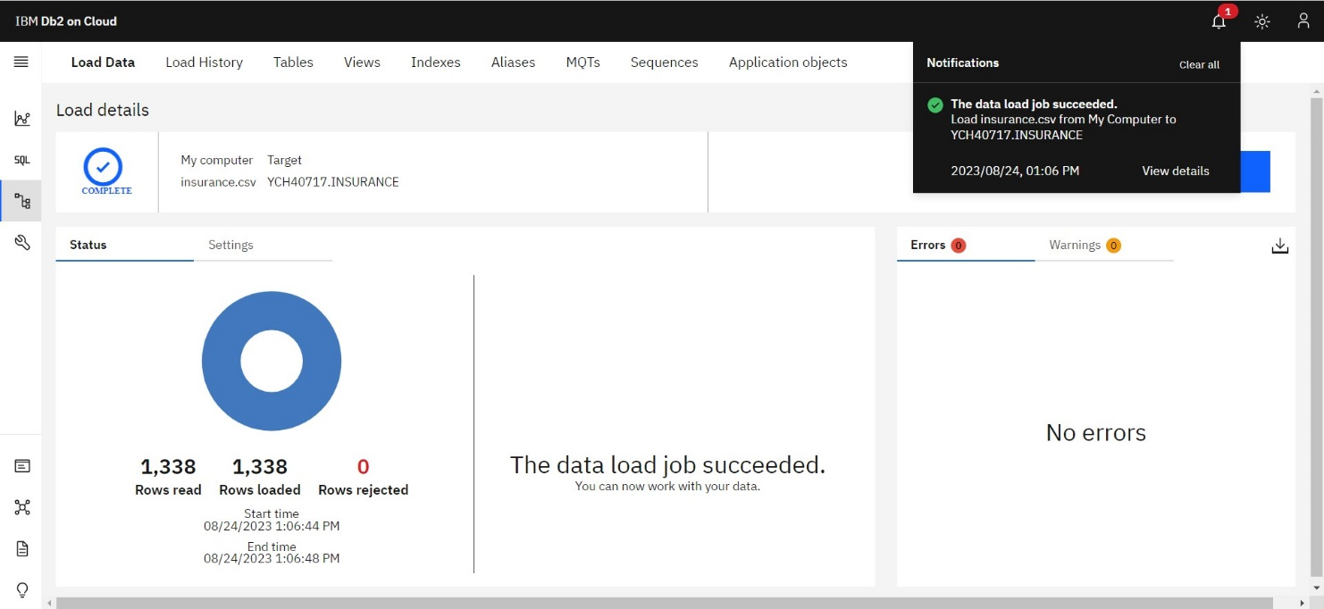

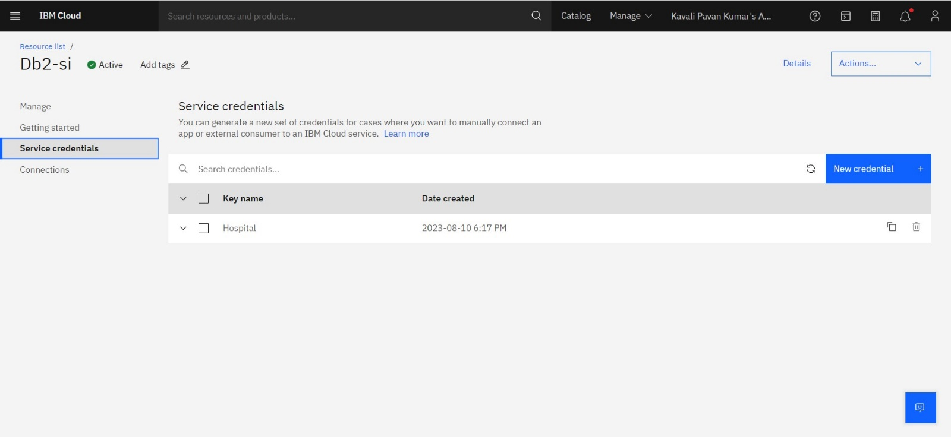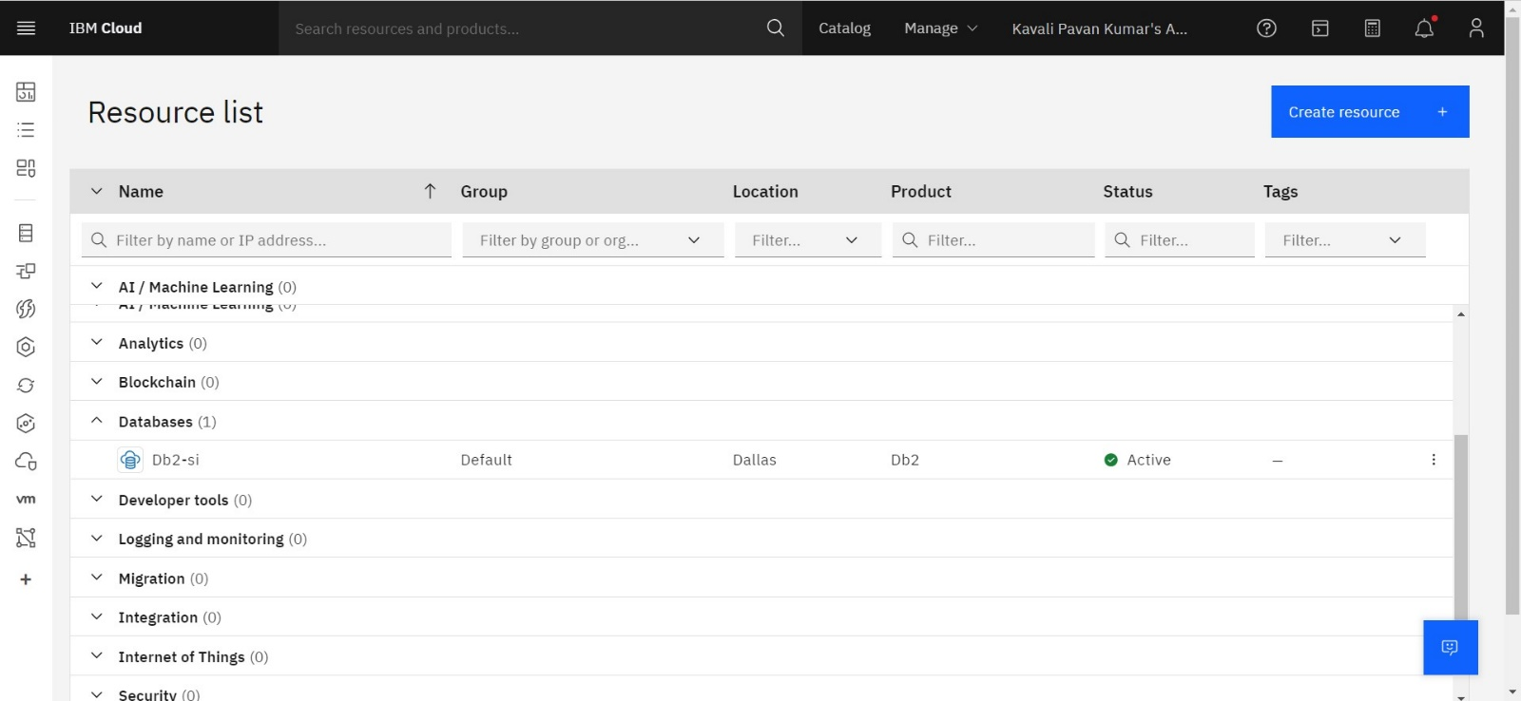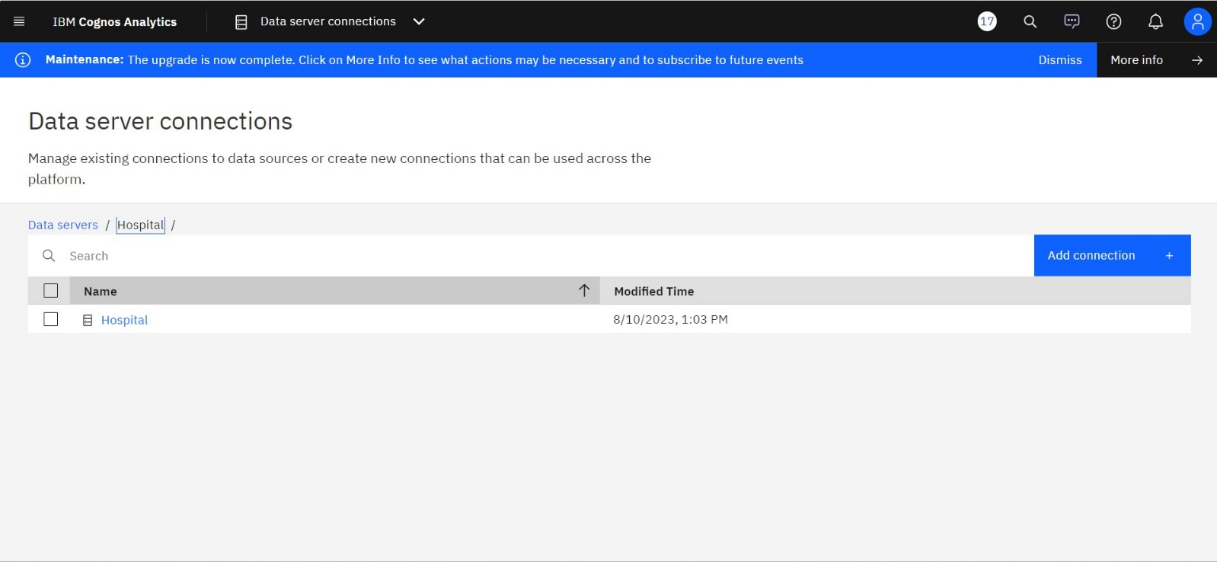

### Data Preparation

In this milestone, we will see how to prepare the data for building visualizations

### Prepare The Data For Visualization

Preparing the data for visualization involves cleaning the data to remove irrelevant or missing data, transforming the data into a format that can be easily visualized, exploring the data to identify patterns and trends, filtering the data to focus on specific subsets of data, preparing the data for visualization software, and ensuring the data is accurate and complete. This process helps to make the data easily understandable and ready for creating visualizations to gain insights into the performance and efficiency.

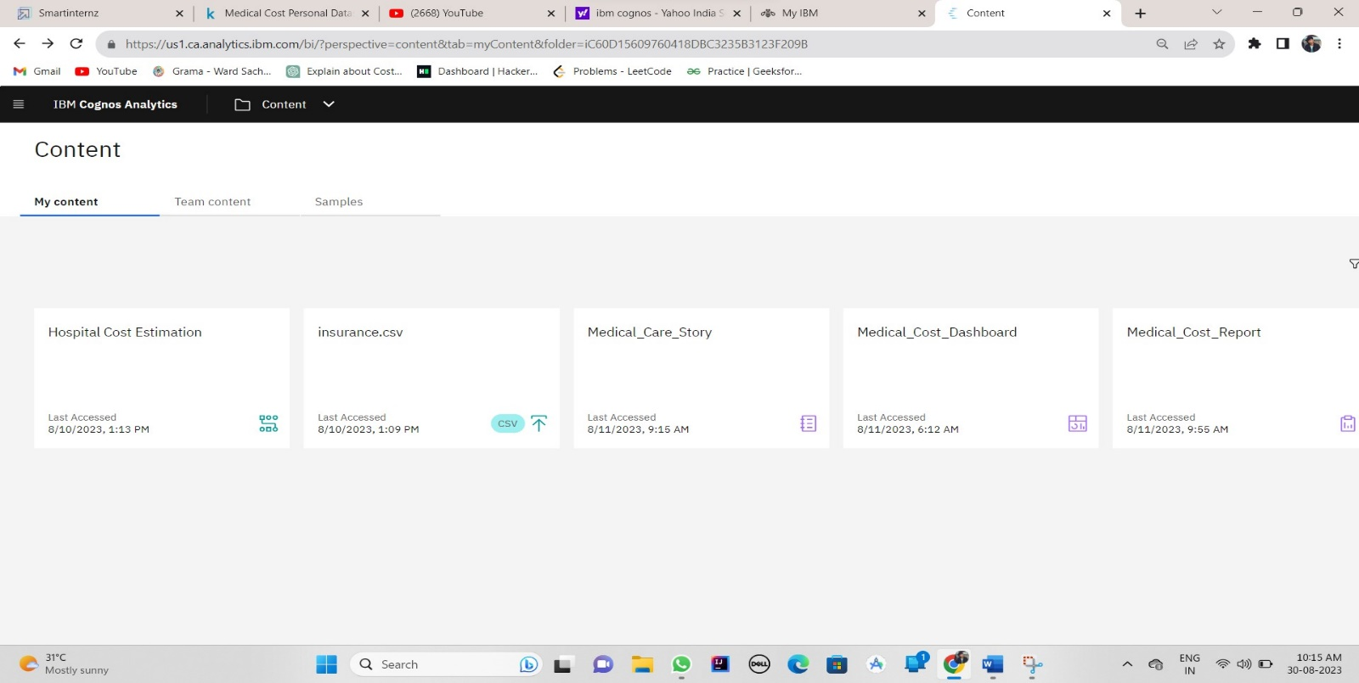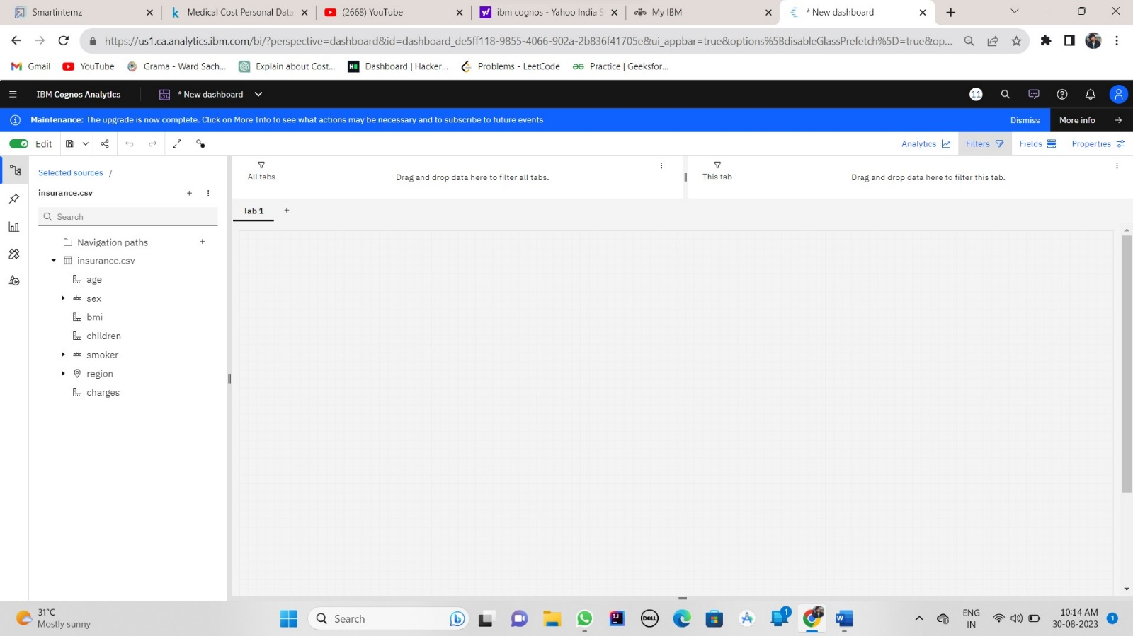

### Data Visualization

Data visualization is the process of creating graphical representations of data in order to help people understand and explore the information. The goal of data visualization is to make complex data sets more accessible, intuitive, and easier to interpret. By using visual elements such as charts, graphs, and maps, data visualizations can help people quickly identify patterns, trends, and outliers in the data.

### No Of Unique Visualizations

The number of unique visualizations that can be created with a given dataset. Some common types of visualizations that can be used to analyze the performance and efficiency of Radisson Hotels include bar charts, line charts, heat maps, scatter plots, pie charts,Maps etc. These visualizations can be used to compare performance, track changes over time, show distribution, and relationships between variables, breakdown of revenue and customer demographics, workload, resource allocation and location of hotels

### Dashboard

A dashboard is a graphical user interface (GUI) that displays information and data in an organized, easy-to-read format. Dashboards are often used to provide real-time monitoring and analysis of data, and are typically designed for a specific purpose or use case. Dashboards can be used in a variety of settings, such as business, finance, manufacturing, healthcare, and many other industries. They can be used to track key performance indicators (KPIs), monitor performance metrics, and display data in the form of charts, graphs, and tables.

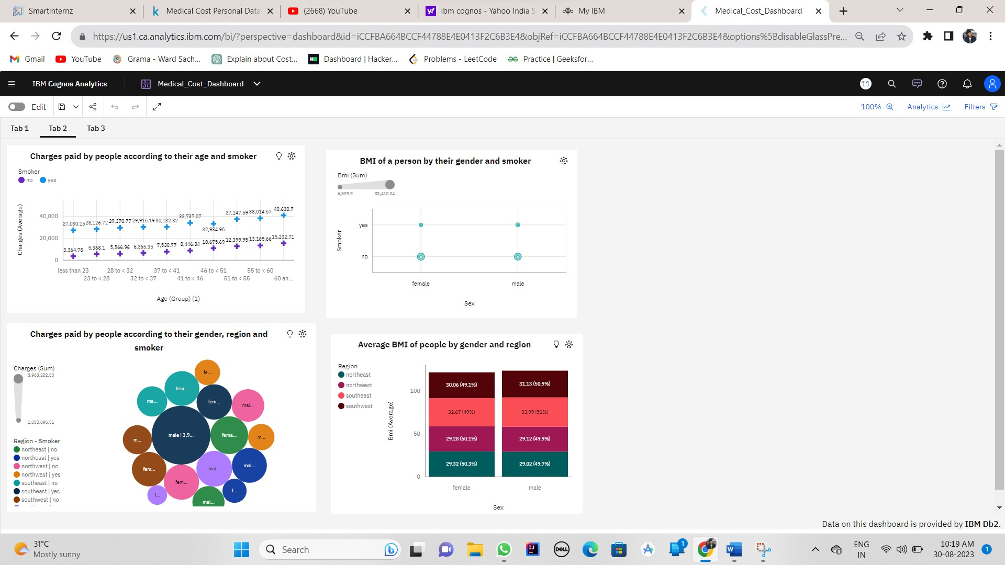

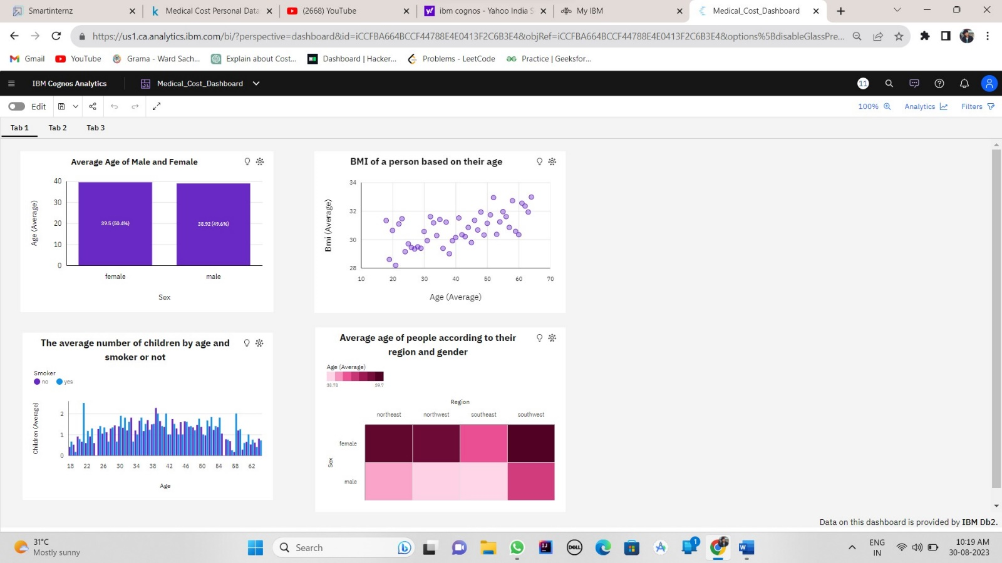

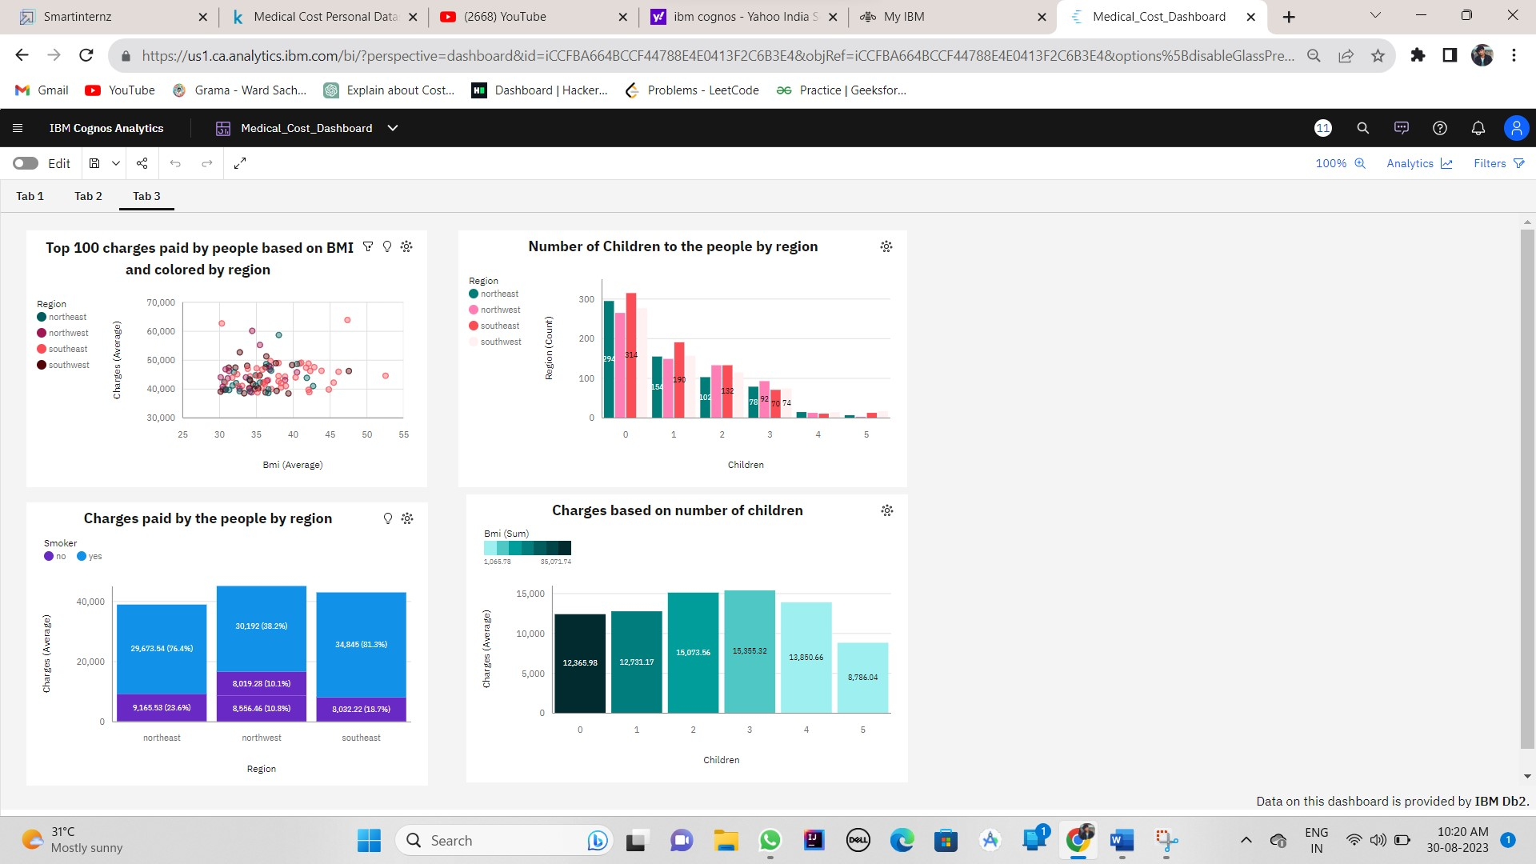

### Responsive And Design Of Dashboard

The responsiveness and design of a dashboard for analysing the factors important for the analysis of medical care cost analysis are crucial to ensure that the information is easily understandable and actionable. Key considerations for designing a responsive and effective dashboard include user-centred design, clear and concise information, interactivity, data-driven approach, accessibility, customization, and security. The goal is to create a dashboard that is user-friendly, interactive, and data-driven, providing actionable insights

Once you have created views on different sheets in IBM Cognos, you can pin them and pull them into a dashboard.

**Note : The all above visualizations have created in the dashboard itself, kindly watch the above links**

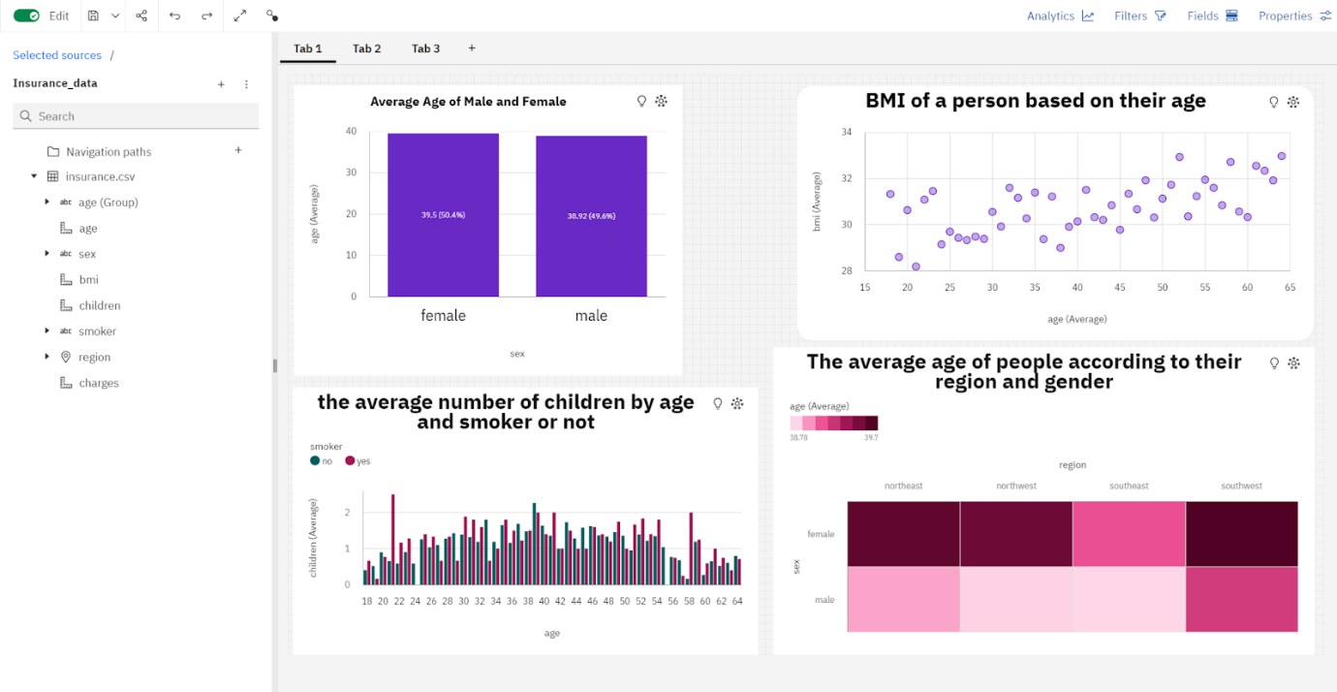

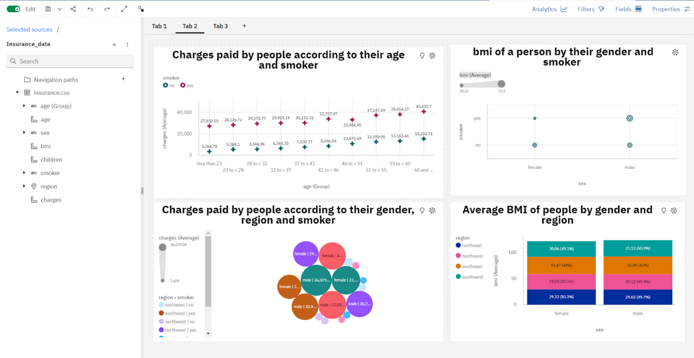

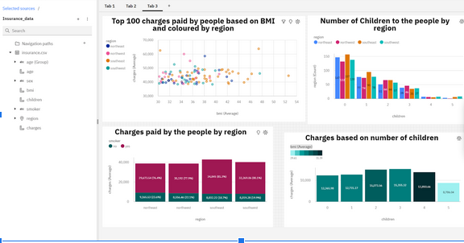

**Story**

A data story is a way of presenting data and analysis in a narrative format, with the goal of making the information more engaging and easier to understand. A data story typically includes a clear introduction that sets the stage and explains the context for the data, a body that presents the data and analysis in a logical and systematic way, and a conclusion that summarizes the key findings and highlights their implications. Data stories can be told using a variety of mediums, such as reports, presentations, interactive visualizations, and videos.

**No Of Scenes Of Story**

The number of scenes in a storyboard for a data visualization analysis of the factors affecting the selection of medical care costs will depend on the complexity of the analysis and the specific insights that are trying to be conveyed. A storyboard is a visual representation of the data analysis process and it breaks down the analysis into a series of steps or scenes.

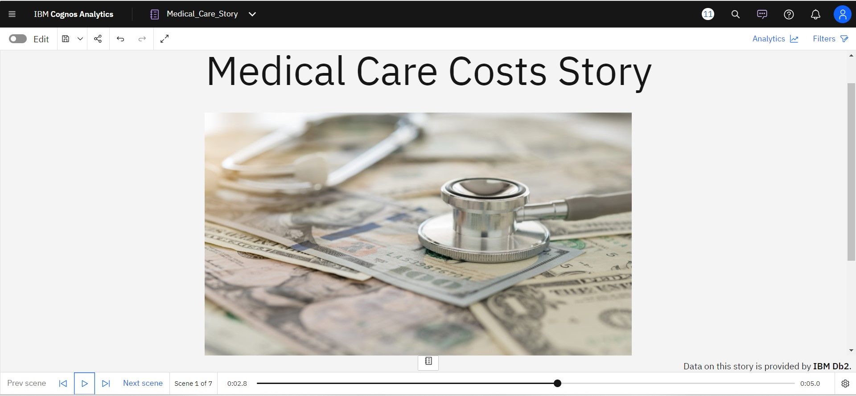

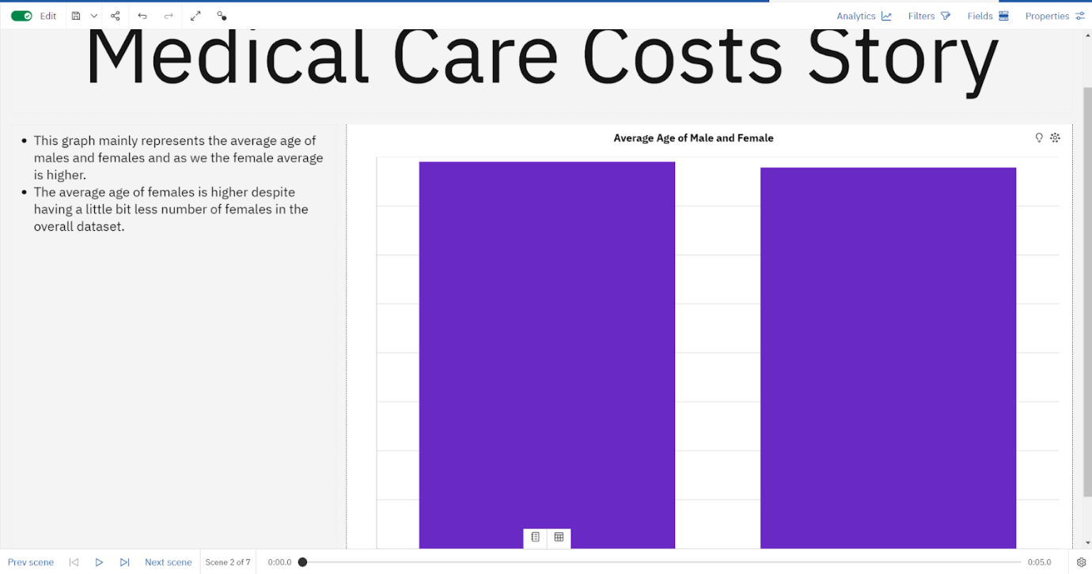

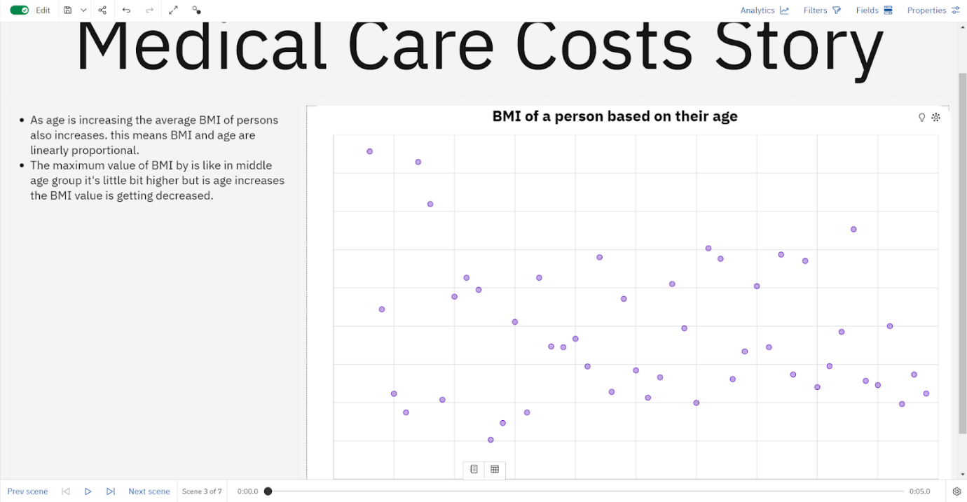

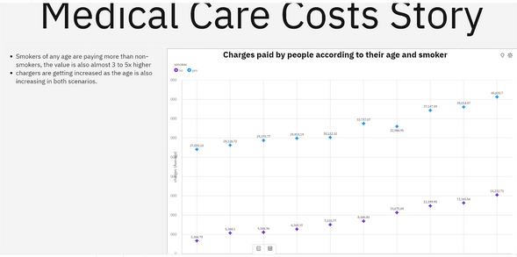

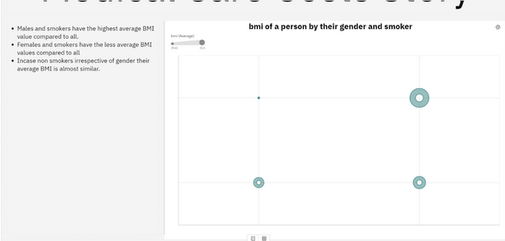

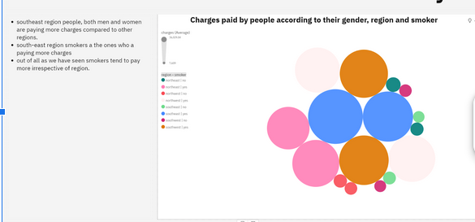

### Report

A report is a document that presents information in a specific format and layout, usually based on data from a database or other data source. A report in IBM Cognos can contain various elements, such as tables, charts, graphs, and images, as well as text and data elements, and it is designed to be used by business users to help them better understand their data and make informed decisions. There are several different types of reports available in IBM Cognos, including list reports, crosstab reports, chart reports, and report studio reports, among others. The type of report that you choose will depend on the specific needs and requirements of your organization, as well as the data that you need to present.

### No Of Visualization With Detail Information

When creating a report in cognos, it is often helpful to include visualizations to help communicate the findings of the analysis.

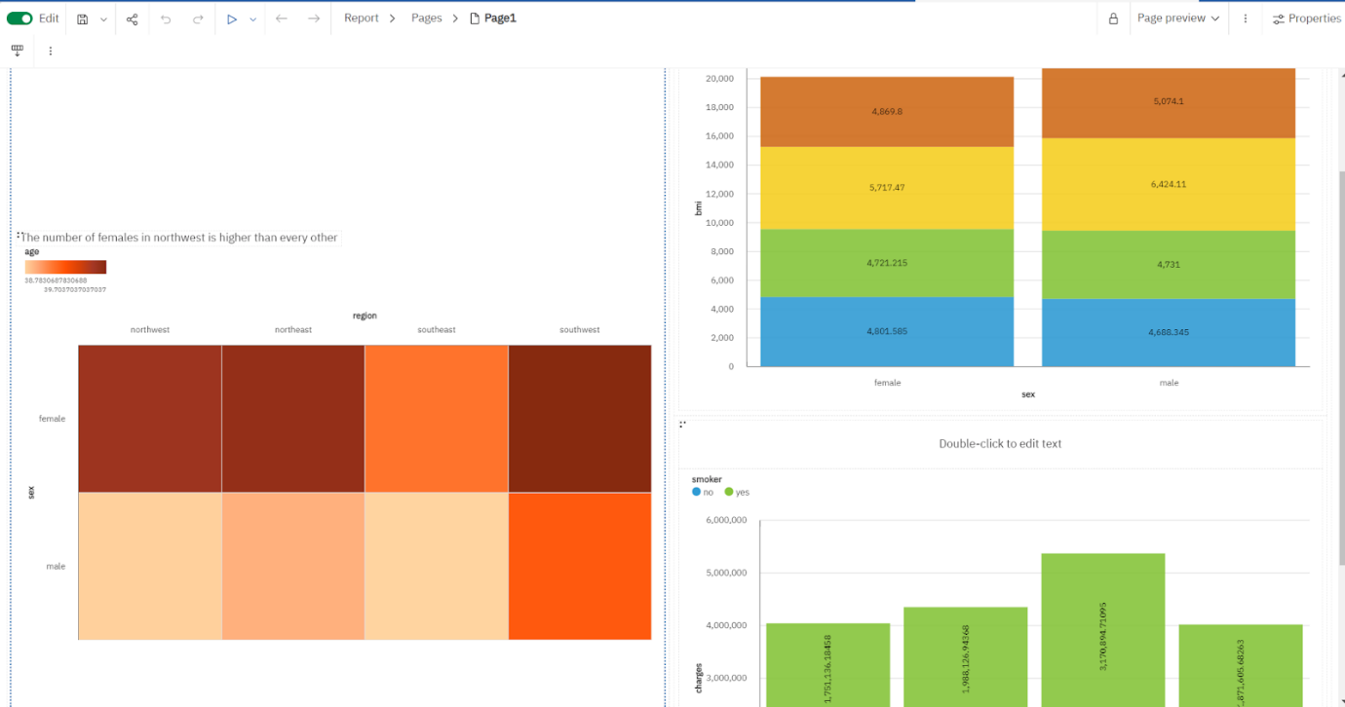

### Performance Testing

### Amount Of Data Rendered To DB2

The amount of data that is rendered to a database depends on the size of the dataset and the capacity of the database to store and retrieve data

**Utilization Of Data Filters**

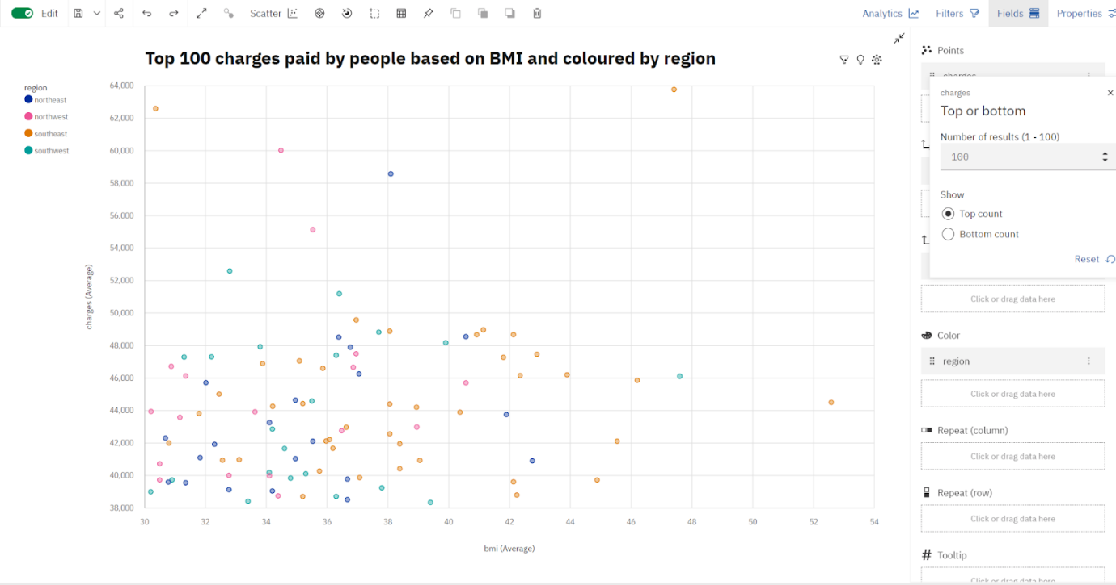

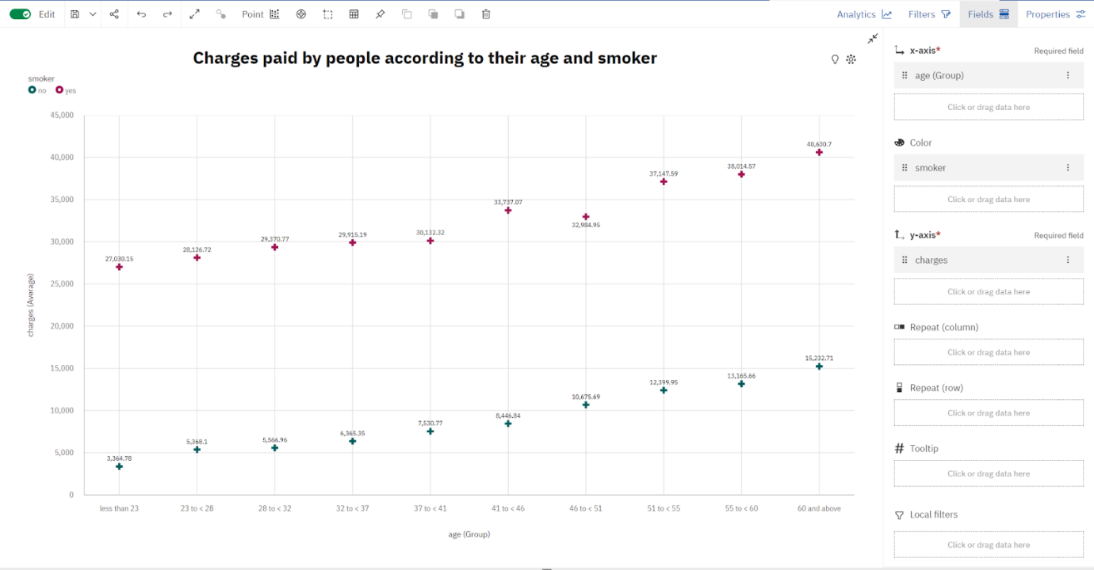

**No Of Calculation Fields**

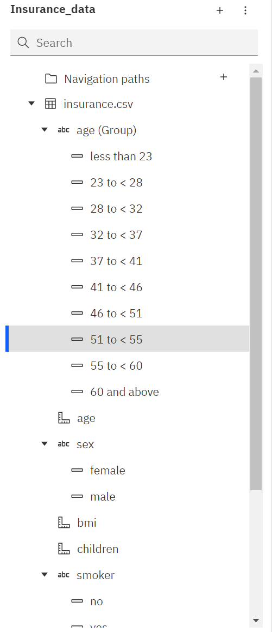

**No Of Visualizations/ Graphs**

* Average Age of Male and Female
* Bmi of a person by age
* Number of children by age and smoker
* The average age of people according to their region and gender
* Charges paid by people according to their age and smoker
* BMI of a person by their gender and smoker
* Charges paid by people according to their gender, region and smoker
* Average BMI of people by gender and region
* Top 100 charges paid by people based on BMI and coloured by region
* Number of Children to the people by region
* Charges paid by the people by region
* Charges based on the number of children

**Web Integration**

Publishing helps us to track and monitor key performance metrics, to communicate results and progress. help a publisher stay informed, make better decisions, and communicate their performance to others.

**Publishing dashboard,report & story.**

Step 1: Go to Dashboard,report & /story, click on share button on the top.

Dashboard

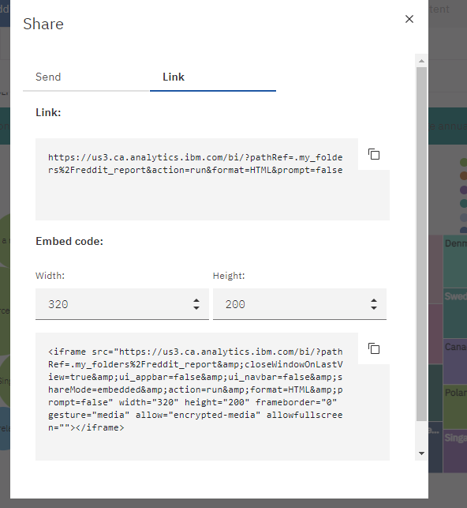

 Copy the’ Embed code’

Note: You can also change the width and height of the dashboard/story/report as you like.

### Dashboard,Report And Story Embed With UI With Flask

### 

### 

### 

### 